Email signature Instructions
For Outlook (classic) Desktop Application
- Open Outlook.
  - Launch the Outlook application on your computer.
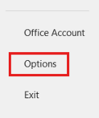
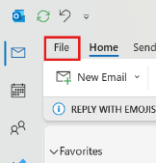
- Go to the Signature Settings.
- Click on the File tab in the top menu.
- Select Options at the bottom left.
- In the Options window, click on Mail in the left-hand menu.
- Click the Signatures… button.
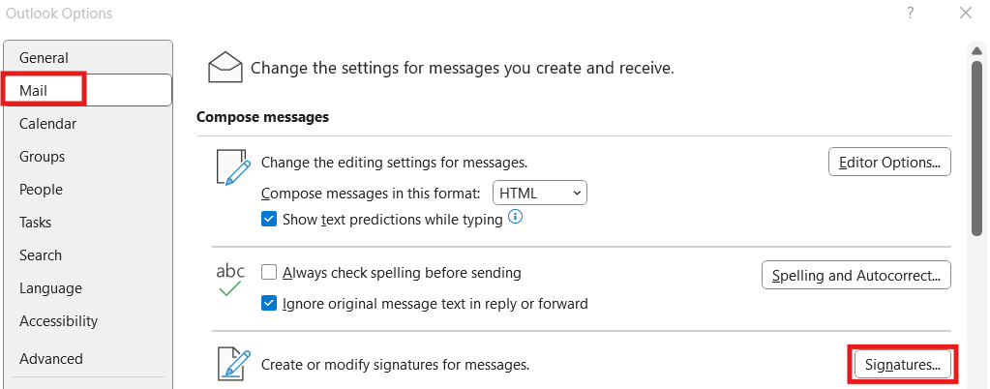
- Create a New Signature.
- In the Signatures window, click New (or select your existing signature).
- Type a name for your signature (e.g., "Professional" or "Personal") and click OK.
- Design Your Signature.
- In the Edit Signature box, type or paste your signature text.
- Copy your agencies template from the pages below. Paste into the signature box.

NOTE: Be sure to paste and keep source formatting.
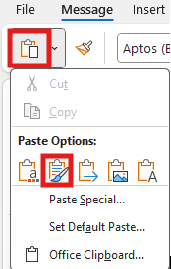
- Add your name, job title, contact information, and any necessary links or images (e.g., a logo or social media icons).
- Set Default Signature.
  - Under Choose default signature, select your new signature for:
    - New messages: Automatically applies the signature to new emails.
    - Replies/forwards: Adds the signature to replies and forwarded emails (optional).
- Save the Signature.
- Click OK to save and close the Signatures and Stationery window.
- Click OK again to close the Options window.

Outlook Web Version (Outlook.com)

- Log in to Your Outlook Account.
  - Open your web browser and go to Outlook.com.
- Access Settings.
  - Click the gear icon (⚙️) in the upper-right corner.
  - Select View all Outlook settings at the bottom.
- Navigate to the Email Signature Settings.
  - In the settings menu, go to Compose and reply.
- Create Your Signature.
  - Under the Email signature section, type or paste your signature text.
  - Format your signature using the toolbar (e.g., font, color, images, or links).
- Apply the Signature Automatically.
  - Check the boxes for:
    - Automatically include my signature on new messages I compose.
    - Automatically include my signature on messages I forward or reply to (optional).
- Save the Signature.
  - Click Save at the bottom of the settings window.

For Reply Signatures:

First and Last Name
Job Title, Company Name
M: 555.123.4567
E: First.Last@lchhfamily.com

NOTE: You can hyperlink your email address in your signature: copy your email address, highlight the entire address, click on the “Link” button and pasting your email address after the link mailto: (no spaces between : and email address).



By company:
 | Full Name Here  Job Title  O: 555.123.4567 Ext. 999  M: 555.123.4567  F: 555.123.4567  E: First.Last@beyondfaithhomecare.com | Beyond Faith Homecare  8535 Wurzbach  Suite 103  San Antonio, TX 78240  BeyondFaithHomecare.com

 | Full Name Here  Job Title  M: 888.803.8888  F: 772.777.7772  E: bruce.wayne@lchhfamily.com | LifeCare Home Health Family  5601 Executive Dr  Suite 250  Irving, TX 75038  www.lchhfamily.com

 | Full Name Here  Job Title  M: 888.803.8888  F: 772.777.7772  E: bruce.wayne@lchhfamily.com | LifeCare Home Health Family  5601 Executive Dr  Suite 250  Irving, TX 75038  www.lchhfamily.com

 | Full Name Here  Job Title  M: 888.803.8888  F: 772.777.7772  E: bruce.wayne@lchhfamily.com | LifeCare Home Health Family  5601 Executive Dr  Suite 250  Irving, TX 75038  www.lchhfamily.com

 | Full Name Here  Job Title  M: 888.803.8888  F: 772.777.7772  E: bruce.wayne@lchhfamily.com | LifeCare Home Health Family  5601 Executive Dr  Suite 250  Irving, TX 75038  www.lchhfamily.com

 | Full Name Here  Job Title  M: 888.803.8888  F: 772.777.7772  E: bruce.wayne@lchhfamily.com | LifeCare Home Health Family  5601 Executive Dr  Suite 250  Irving, TX 75038  www.lchhfamily.com

 | Full Name Here  Job Title  M: 888.803.8888  F: 772.777.7772  E: Bruce.Wayne@lchhfamily.com | LifeCare Home Health Family  5601 Executive Dr  Suite 250  Irving, TX 75038  www.lchhfamily.com

 | Full Name Here  Job Title  M: 888.888.7880  F: 772.770.6777  E: Bruce.Wayne@lchhfamily.com | LifeCare Home Health Family  5601 Executive Dr  Suite 250  Irving, TX 75038  www.lchhfamily.com

Support Center

Full Name Here  Job Title  O: 555.123.4567  M: 555.123.4567  E: First.Last@lchhfamily.com | LifeCare Home Health Family  5601 Executive Dr  Suite 250  Irving, TX 75038  LCHHfamily.com


